

**Carrier 6.0HP Non-Inverter**

**Rs. 137,200/-**

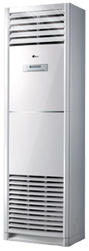

**Product Features**

* Self-diagnostic Function
* 15M Long Distance Airflow
* super quiet mode
* comfortalble sleep mode
* evaporator self-cleaning

**Specification**

**Type** Wall Mounted Split AC

**Cooling (Btu/h)** 51000

**Voltage (V)** 220-240

**Power Input (W)** 4300

**EER (Btu/W-h-W/W)** 6.4-3.45